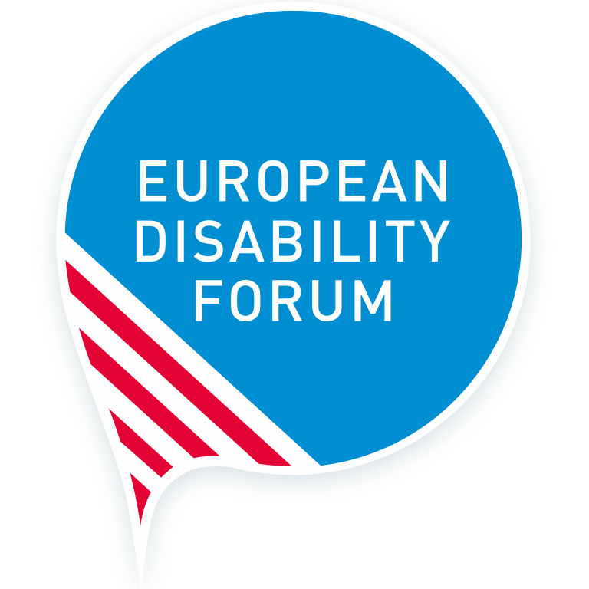
Forced sterilisation of persons with disabilities in the European Union
  - European Disability Forum – Report
  - September 2022
This publication has received financial support from the European Union. The information contained in this publication does not necessarily reflect the official position of the European Commission.
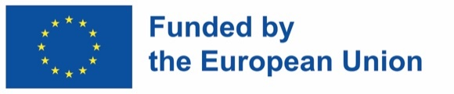
Easy-to-read version

European Disability Forum
 | The European Disability Forum is also known as EDF. It is made up of over 100 organisations who speak up for persons with disabilities.
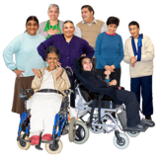 | We are run by persons with disabilities and their families.
 | We are a strong and united voice in Europe.
 | EDF is working with other organisations to end violence against women and girls.

Background
 | Forced sterilisation is when a person is made to have an operation against their will which stops them from being able to have children.
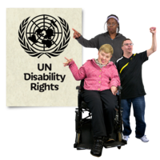 | This is against their human rights.
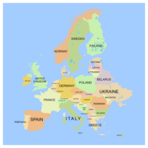 | It can happen to people with disabilities, Roma and intersex people across Europe and the rest of the world.
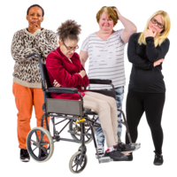 | It usually happens to women and girls, more than to men and boys.
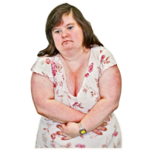 | Forced sterilisation is cruel. It is a type of torture and can affect the person for a very long time.
 | This report shows more about this terrible situation and calls for forced sterilisation to be banned in Europe and the rest of the world.

Human rights law and forced sterilisation

International human rights treaties ban forced sterilisation which is against these rights:
- The right to dignity
- The right to choose what happens to your own body
- The right to privacy
- The right to make your own decisions

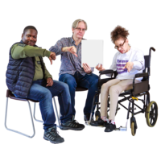 | Many articles in the UNCRPD (United Nations Convention on the Rights of Persons with Disabilities) say forced sterilisation is wrong and must be stopped.
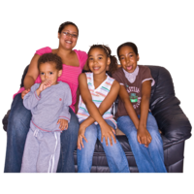 | For example, Article 23 is the right to have a family.
 | Other international treaties also say that forced sterilisation is wrong and cruel. They all say it must be stopped.
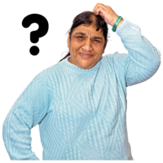 | Most EU Member states agree with these laws and treaties. But they don’t always follow them and they allow forced sterilisation to happen.

Forced sterilisation in EU Member states
 | There is still forced sterilisation happening in 14 EU states. This is mainly on women and girls who have intellectual disabilities.
 | There are some countries which do not allow forced sterilisation, except when it is for an urgent or special reason.
 | The agreement to do forced sterilisation is often done in secret. So it is hard for EDF to find out exactly how often it happens.
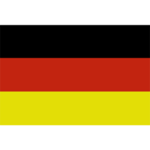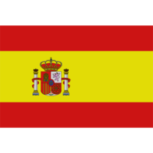 | Germany and Spain have better information. Many more women with disabilities are sterilised compared to women without disabilities.
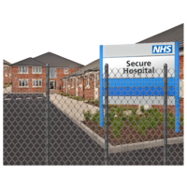 | In Belgium, Lithuania and Poland women who live in institutional care are often victims of forced sterilisation.

The reasons given for forced sterilisation include:
- Medical reasons
- To protect the person from sexual abuse
- To prevent the person having to use contraception
- Thinking the person with a disability won’t be able to look after a child
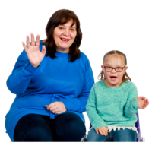 | No person should go through forced sterilisation. It stops people from being a parent. People with a disability have a right to be parents.
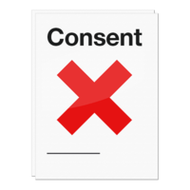 | But sterilisation is done in many countries without a person’s knowledge or consent.
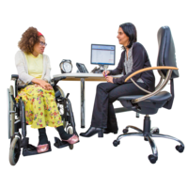 | These countries say that if a person doesn’t understand, then a legal guardian or a doctor can agree to forced sterilisation.
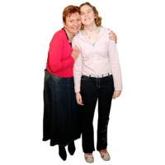 | In Portugal and Croatia parents can ask for their adult child to be sterilised.
 | In some countries a judge can decide if the operation to sterilise can go ahead.
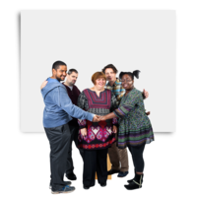 | Some countries say forced sterilisation is to ‘protect vulnerable people’. But this is against the right to self-determination. This is the right to choose how you live your life and what happens to you.
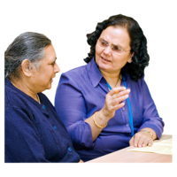 | Some countries do tell people if they are going to have a forced sterilisation. But it is not known if they give this information in a person-centred way.
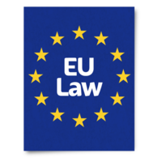 | Most EU Member states do not have laws that cover forced sterilisation. Malta and Sweden do have laws that make it a criminal offence.
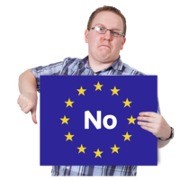 | In Denmark and Slovakia, it is banned under mental health laws.

Justice for victims and good examples
 | There are not many member states who support and compensate women who have been victims of forced sterilisation.
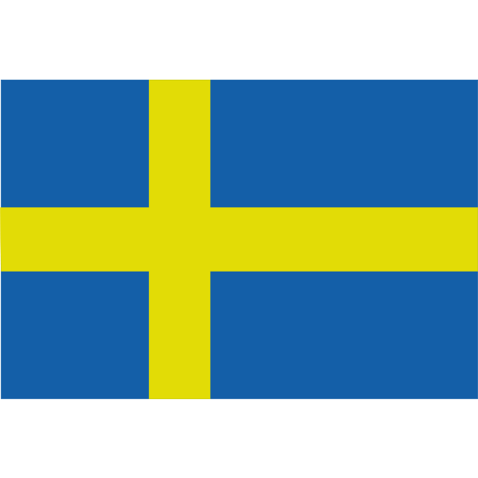 | Sweden stopped forced sterilisation in 1975, and now it gives compensation money for victims.
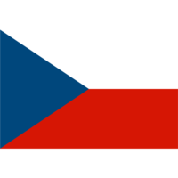 | Czechia used to do forced sterilisation to people with a disability and Roma people. From 2021 they have been compensating victims.
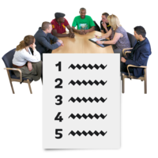 | Slovakia is talking about giving compensation.

What should happen now?
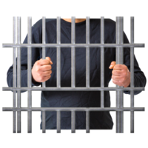 | Forced sterilisation must be stopped and made a criminal offence by the EU and all the EU Member states.
 | There must also be compensation for victims.
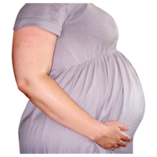 | Sexual rights and the right to be a parent must be guaranteed.
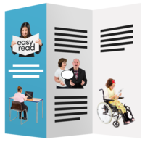 | There must be free and clear information about:  - the right to have a family  - contraception  - sex education  - getting a safe abortion  - support for good health of the parts of the body that make babies  - support to be a parent

More information is available in the full report on forced sterilisation in the English language.
Contact details
Marine Uldry, Senior Human Rights Officer:
marine.uldry@edf-feph.org
EDF Secretariat: info@edf-feph.org
The European Disability Forum
Mundo Madou
Avenue des Arts 7-8
1210 Brussels, Belgium.

Views and opinions expressed are however those of the author(s) only and do not necessarily reflect those of the European Union or the European Commission. Neither the European Union nor the granting authority can be held responsible for them.

